***Assignment 4***



Name:

FCU ID:

Team number:

**Topic of this class: Descriptive statistics & diagrams**

Descriptive statistics is a scientific method that assist innovators to describe, present or summarize the meaningful information after data analysis. It can be broken down into measures of central tendency and measures of spread (or variability), which:

* **Measures of central tendency** are ways to describe the central position of a distribution data, including the mean, median, and mode.
* **Measure of spread** are ways to summarize how wide the data distribution spread out, including range, standard deviation, variance and quartiles.

By doing this, innovators try to capture a large set of observations and give people some idea about the data set. After that, the group of data can be represented in the form of graphs, histograms or other types of diagram or table to better understand what is happening in the experiment or survey.

|  |
| --- |
| **Learning objectives:**  *New abilities:*   * **ET05:** Create a histogram with meaningful number of bins and width/sizes. * **DA02:** Describe, with calculations, variability of data using statistical methods (standard deviation, variance). * **DA03:** Make accurate comparisons across groups with explicit reference to data. * **DA04:** Given independent and dependent variables, interpret or predict the performance of a solution. * **DA05:** Given two variables, describe the relationship and/or calculate the strength of the correlation between these variables. * **DA06:** Interpret the distribution of data in a graph * **PC02:** Make clear and complete arguments or statements by fully addressing all parts of the assignment. * **SQ02:** Justify design solution based on how well it meets criteria and constraints.   *Review what you learn before:*   * **ET03:** Justify graphical representation based on data characteristics. * **ET04:** Prepare chart or table for technical presentation with proper formatting (headers, units, meaningful decimal points, appropriately scaled axes, appropriately sized marker and axis labels). * **DA01:** Describe, with calculations, the central tendency of data using descriptive statistics (mean, median, and mode). * **UC01:** Demonstrate an understanding of conservation principles (mass, energy, momentum, and/or charge) in a boundary system. * **UC02:** Describe systems or processes using schematic diagrams with inputs, outputs, and accumulations. * **PC01:** Use professional communication (written, visual, and oral), free of grammatical or spelling mistakes and in a formal tone, appropriate for engineering school and workplace. * **PA01:** Identify strengths and limitations in one’s problem solving/design approach. * **SQ01:** Use accurate, scientific, mathematical, and/or technical concepts, units, and/or data in solutions.   ***You will be graded on completion of the above objectives!*** |

1. **Individual activity: Problem analysis practice.**

Below are data for the median family income in the United States by Race and Hispanic Origin, for the years 1972-1987. The data are in current dollars. If you work in Ministry of Finance and State Administration of Taxation, try to analysis the data.

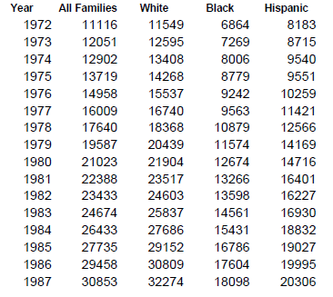

**Answer columns:**

|  |
| --- |
| 1. **How many variables are there in the data, what are they?** |
|  |
| 1. **Try to write a report title for the data analysis** |
|  |
| 1. **Try to write 5 independent sentences to describe the data** |
| **1.**  **2.**  **3.**  **4.**  **5.** |
| 1. **Try to represent the data in 2 different types of diagrams** |
|  |

1. **Individual activity: Descriptive statistic practice.**
   1. Try to measure the central tendency (mean, median & mode) and spread (range, standard deviation, variance & quartiles) for the two data set below, (1) cities with mostly men, (2) cites with mostly women.
   2. Represent your data by diagrams and write a memo to describe the data.

Table 1. Number of unmarried men per 100 unmarried women in U.S. Metro Areas in 1990.

|  |  |  |  |
| --- | --- | --- | --- |
| Cities with mostly men | Men per 100 Women | Cities with mostly women | Men per 100 Women |
| 1. Jacksonville, NC | 224 | 1. Sarasota, FL | 66 |
| 2. Killeen-Temple, TX | 123 | 2. Bradenton, FL | 68 |
| 3. Fayetteville, NC | 118 | 3. Altoona, PA | 69 |
| 4. Brazoria, TX | 117 | 4. Springfield, IL | 70 |
| 5. Lawton, OK | 116 | 5. Jacksonville, TN | 70 |
| 6. State College, PA | 113 | 6. Gadsden, AL | 70 |
| 7. Clarksville-Hopkinsville, TN-KY | 113 | 7. Wheeling, WV | 70 |
| 8. Anchorage, Alaska | 112 | 8. Charleston, WV | 71 |
| 9. Salinas-Seaside-Monterey, CA | 112 | 9. St. Joseph, MO | 71 |
| 10. Bryan-College Station, TX | 111 | 10. Lynchburg, VA | 71 |

NOTE: Unmarried includes never-married, widowed, and divorced persons.

**Answer columns:**

|  |
| --- |
| * 1. **(1) Cities with mostly men** |
|  |
| * 1. **(2) Cities with mostly women** |
|  |
| * 1. **Diagrams & memo** |
|  |

1. **Team activity: Engineering statistics.**

This following file contains the grades for RobotC competition. There are five challenges in this competition, including speed, weightlifting, obstacle race, accuracy, and cost. Try to write a statistic report for this competition (**PAE 2**). The report must be based on detailed analysis, including text description and diagrams (histogram, line chart and pie chart).

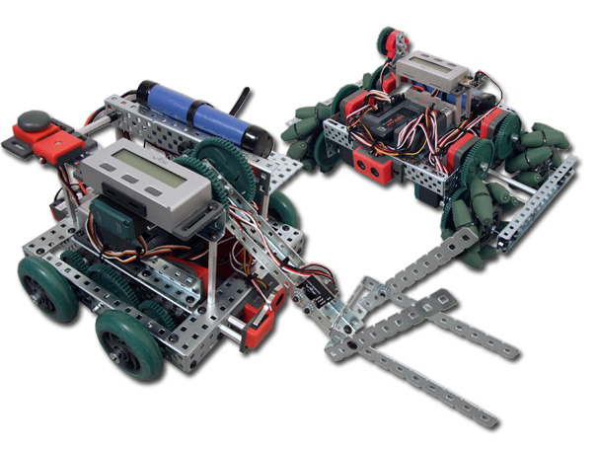

https://sites.google.com/a/westcta.ccsd.net/dominickc346/program-hilights

|  |  |  |  |  |  |  |  |
| --- | --- | --- | --- | --- | --- | --- | --- |
|  | | NAME | Speed | Weightlifting | Obstacle race | Accuracy | Cost |
| 1 | | Stevens, Tony | 64 | 70 | 73 | 85 | 75 |
| 2 | | Rivers, Tina | 70 | 77 | 88 | 95 | 90 |
| 3 | | Beal, Jenny | 77 | 83 | 79 | 88 | 80 |
| 4 | | Calhoun, Richard | 69 | 43 | 81 | 78 | 75 |
| 5 | | Nixon, Rachel | 91 | 90 | 86 | 95 | 88 |
| 6 | | Freeman, Ralph | 44 | 26 | 54 | 78 | 80 |
| 7 | | Copely, Roy | 61 | 67 | 70 | 85 | 80 |
| 8 | | Kimmett, Roger | 77 | 85 | 86 | 85 | 85 |
| 9 | | Allen, Renae | 83 | 86 | 92 | 85 | 88 |
| 10 | | Victor, Isaac | 97 | 80 | 82 | 85 | 88 |
| 11 | | Albright, Alan | 69 | 69 | 50 | 85 | 75 |
| 12 | | Bredder, Richard | 96 | 92 | 92 | 98 | 85 |
| 13 | | Gaby, Brad | 95 | 89 | 89 | 95 | 85 |
| 14 | | Hendrix, James | 91 | 84 | 92 | 95 | 85 |
| 15 | | Fonzerelli, Arthure | 87 | 79 | 84 | 85 | 80 |
| 16 | | Cunningham, Richar | 76 | 73 | 80 | 82 | 80 |
| 17 | | Van Dyke, Robert | 84 | 75 | 78 | 88 | 80 |
| 18 | | Thompson, June | 82 | 84 | 78 | 88 | 85 |
| 19 | | Ashe, David | 70 | 41 | 57 | 73 | 70 |
| 20 | | Pepper, Claude | 79 | 84 | 77 | 82 | 80 |
| 21 | | Lemeiux, Felix | 84 | 67 | 78 | 88 | 80 |
| 22 | | Regan, Rhonda | 97 | 93 | 92 | 92 | 85 |
| 23 | | Walton, Christine | 87 | 73 | 82 | 90 | 88 |
| 24 | | Census, James | 65 | 38 | 84 | 85 | 85 |
| 25 | | Richardson, Natasha | 79 | 75 | 85 | 75 | 75 |
| 26 | | Montana, Joseph | 71 | 80 | 78 | 88 | 90 |
| 27 | Hindes, Martina | | 96 | 80 | 96 | 98 | 95 | |
| 28 | Levert, Christine | | 98 | 95 | 96 | 98 | 95 | |
| 29 | Tucker, Peter | | 87 | 78 | 86 | 82 | 80 | |
| 30 | Blackwood, Rita | | 59 | 42 | 54 | 75 | 75 | |
| 31 | Mahler, Blake | | 84 | 92 | 93 | 90 | 90 | |
| 32 | Black, Susan | | 51 | 67 | 76 | 78 | 80 | |

|  |  |  |  |  |  |  |  |  |  |  |
| --- | --- | --- | --- | --- | --- | --- | --- | --- | --- | --- |
| **Grade** | A | A- | B+ | B | B- | C+ | C | C- | D | F |
| **Value** | >94 | 90-93 | 87-89 | 84-86 | 80-83 | 77-79 | 74-76 | 70-73 | 60-69 | <59 |

**Before writing up your report…**

|  |
| --- |
| **Try to design a contents for it** |
|  |

1. **Individual contributions**

Individually, each team member should describe his/her contributions to these activities.

|  |  |
| --- | --- |
| **Team member name** | **Team members’ contribution to the team activities above** |
|  |  |
|  |  |
|  |  |
|  |  |